Gardener F5 Application Load Balancer Extension
Part 3 - Service (type=LoadBalancer) Detailed Design
Implementation-oriented low-level design
Version 1.0 | July 2026

Document Purpose and Scope
This part defines the complete reconciliation design for Kubernetes Services with spec.type=LoadBalancer. It continues the architectural foundation and internal desired-state model established in Parts 1 and 2. The focus is implementation: what the controller reads, what it validates, how it resolves backends, which CMP resources it creates, how it converges after change or failure, and how it safely deletes owned resources.
Normative design rule
Kubernetes objects are the source of desired intent. CMP/F5 resources are managed outputs. Controllers do not directly orchestrate provider calls; they delegate to model builders and deployment managers.

Reading Guide
- “Service” means a Kubernetes core/v1 Service with spec.type=LoadBalancer.
- “LB Service” means the CMP top-level application load-balancer service resource.
- “Virtual Server” means the CMP/F5 listener/front-end configuration for one Service port.
- “Pool” means the backend group associated with one Virtual Server.
- “Member” means one resolved backend attached to a Pool.
- “Observed state” means resources returned by CMP discovery APIs.
- “Desired state” means the internal LoadBalancerStack built from Kubernetes input.

Table of Contents
3.1 Design Objectives
3.2 Service Reconciliation Overview
3.3 Kubernetes Service Analysis
3.4 Validation
3.5 Backend Discovery
3.6 Desired State Generation
3.7 Resource Mapping
3.8 Deployment Algorithm
3.9 Status Update
3.10 Failure Recovery
3.11 Delete Flow
3.12 Sequence Diagrams
3.13 Design Decisions
3.14 Summary and Implementation Checklist

3.1 Design Objectives

3.1.1 What Kubernetes Guarantees
Kubernetes provides an eventually consistent API and a stable Service abstraction. The extension can rely on the API server to persist intent and on EndpointSlice objects to represent the current backend set. Kubernetes does not guarantee that an external provider operation has completed when the Service object is accepted; the controller must establish that convergence itself.
Kubernetes guarantee | Design implication
Service object is durable and versioned | Every reconcile reads the latest object and treats resourceVersion conflicts as retryable.
EndpointSlice reflects selected endpoints | Backend membership is derived from EndpointSlice, not inferred by listing Pods from the selector.
Deletion is two-phase when finalizers exist | The extension can block final deletion until owned CMP resources are removed.
Status is controller-owned output | The extension patches status.loadBalancer and controller-specific conditions only after verification.
Events may be duplicated or missed | Reconciliation must be idempotent and periodic resync must be safe.

3.1.2 What the Extension Must Guarantee
- Only eligible Services are managed; non-target Services remain untouched.
- Equivalent input produces equivalent logical desired state.
- Provider mutation is ordered according to CMP resource dependencies.
- No provider resource is adopted, changed, or deleted without verified ownership.
- Multi-port Services produce deterministic listener and pool mappings.
- Backend-only changes do not recreate stable front-end resources.
- Status is not used as the source of truth for provider existence.
- Controller restart, duplicate events, and transient CMP failures converge without leaking resources.
- Deletion is dependency-aware and finalizer removal occurs only after cleanup is verified.

3.1.3 Non-goals
- Implementing general-purpose Ingress host/path routing; that belongs to Part 4.
- Managing unrelated CMP/F5 resources that were created outside this extension.
- Using Pod IPs as direct backends unless a future CMP-supported backend mode is explicitly designed.
- Encoding CMP transport concerns into controller or model-builder code.
- Providing partial support for Kubernetes features that cannot be faithfully represented in CMP.

3.2 Service Reconciliation Overview
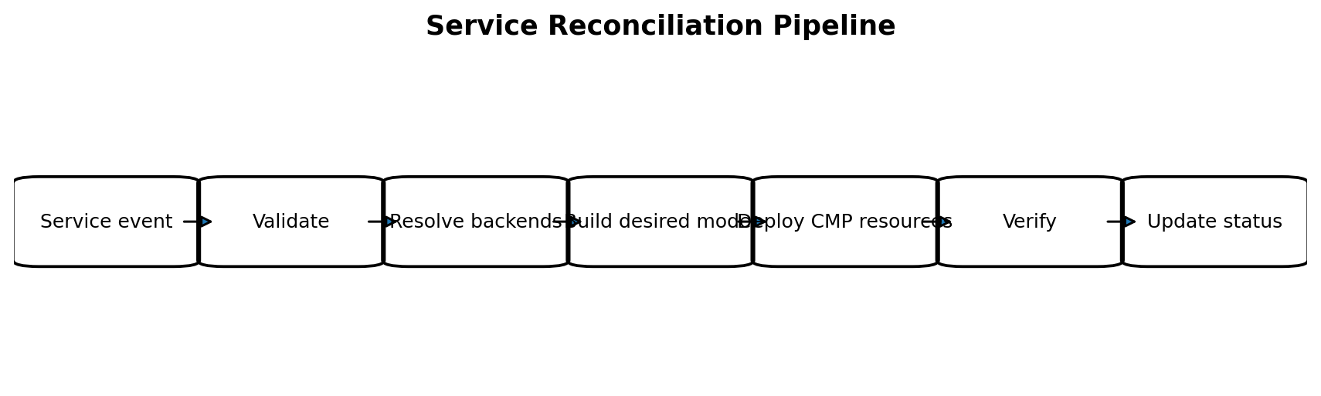
Figure 3-1. End-to-end Service reconciliation pipeline.
A reconciliation request is a request to converge, not a request to perform a particular CRUD operation. The controller always reconstructs the latest snapshot, rebuilds the full desired model, and asks deployment managers to converge observed CMP resources toward that model.

3.2.1 Controller Responsibilities
Controller does | Controller does not
Fetch Service and related Kubernetes objects | Construct raw CMP HTTP requests
Check eligibility and deletion state | Encode resource dependency ordering
Invoke validation and backend resolution | Perform ad-hoc provider retries
Invoke the model builder | Store provider state in process memory
Invoke the stack deployer | Directly create VIPs, pools, or members
Record events and patch status | Assume an event represents the complete current state

3.2.2 Reconcile Contract
Reconcile(ctx, NamespacedName) -> Result, error
1. Read the latest Service.
2. If not found: return; deletion is handled while finalizer exists.
3. If not eligible and not previously owned: return.
4. If deleting: execute cleanup path.
5. Ensure finalizer.
6. Build a consistent Kubernetes input snapshot.
7. Validate the snapshot.
8. Resolve provider-specific backend identities.
9. Build LoadBalancerStack.
10. Deploy and verify the stack.
11. Patch status and conditions.
12. Requeue only when convergence or observation requires it.

3.2.3 Event Sources
Watched object | Reason | Enqueue key
Service | Desired front-end or policy change | Service namespace/name
EndpointSlice | Backend readiness, addition, or removal | Owning Service label
Node | Node addresses, provider ID, readiness, or topology change | All affected Services
Secret or configuration object | Credential, TLS, or provider option change where supported | Referenced Services
Periodic resync | Recovery from missed events or out-of-band drift | All managed Services

3.3 Kubernetes Service Analysis
The model builder receives a normalized ServiceInput rather than a raw Service. Normalization removes API representation differences and makes all defaulting explicit. The following table identifies fields that affect the design.
Field | Used? | Design usage | Validation note
metadata.uid | Yes | Stable source identity and ownership key | Required for ownership; never derived from name alone
metadata.namespace/name | Yes | Human-readable naming and event correlation | Names may be reused after deletion; UID remains authoritative
metadata.annotations | Yes | CMP options explicitly supported by the extension | Unknown extension-prefixed annotations are rejected
metadata.deletionTimestamp | Yes | Selects cleanup flow | Mutations other than cleanup are forbidden while deleting
spec.type | Yes | Eligibility | Must equal LoadBalancer
spec.loadBalancerClass | Yes | Controller selection | Must be absent under legacy mode or equal configured class
spec.ports | Yes | Listener, pool, member service port and health settings | Port identity must remain unambiguous
spec.selector | Indirectly | Kubernetes uses it to produce EndpointSlices | Controller consumes EndpointSlices, not Pod listing
spec.externalTrafficPolicy | Yes | Determines local or cluster backend semantics | Local requires endpoint/node locality awareness
spec.sessionAffinity | Yes when supported | Maps to CMP persistence profile | Unsupported ClientIP options are rejected
spec.loadBalancerSourceRanges | Optional | Maps to front-end source restrictions if CMP supports it | Rejected when CMP cannot represent it
spec.ipFamilies / ipFamilyPolicy | Yes for validation | Ensures selected address family is supported | No silent IPv4/IPv6 downgrade
spec.allocateLoadBalancerNodePorts | Yes | NodePort backend precondition | Must be true or defaulted true for NodePort mode
spec.healthCheckNodePort | Conditional | Local-policy health checking where applicable | Read-only input; must be allocated by Kubernetes
status.loadBalancer | Output only | Published VIP/IP or hostname | Never used to discover provider resources
spec.clusterIP / clusterIPs | No for CMP front end | Internal Service routing only | Not translated into CMP resources
spec.internalTrafficPolicy | No | Controls in-cluster traffic | Not an external LB concern

3.3.1 Service Port Identity
Each Service port must map to one stable logical listener identity. The identity is not the array index because ordering may change. The recommended logical key is: port name when present; otherwise protocol plus service port. The builder must reject duplicates after normalization.
servicePortKey(port):
if port.name != "":
return "name:" + port.name
return lower(port.protocol) + ":" + decimal(port.port)
logicalVirtualServerID = serviceUID + "/vs/" + servicePortKey
logicalPoolID = serviceUID + "/pool/" + servicePortKey

3.3.2 Annotation Design
Annotations are a compatibility surface and therefore must be few, typed, documented, and versioned. They should override optional policy, not replace core Kubernetes semantics.
Annotation category | Examples of intent | Rule
Placement | CMP project, network, subnet, availability zone | Prefer controller configuration or Gardener infrastructure context; allow override only when required
Frontend | Requested VIP, internal/external exposure | Validate immutability and address-family support
Pool | Load-balancing algorithm, connection limits | Map only to verified CMP enum values
Health | Monitor protocol, interval, timeout, path | Defaults must be deterministic per Service protocol
Lifecycle | Deletion protection or retain-on-delete if policy allows | Must not bypass ownership checks
Observability | Optional correlation labels | Cannot alter ownership identity

3.4 Validation
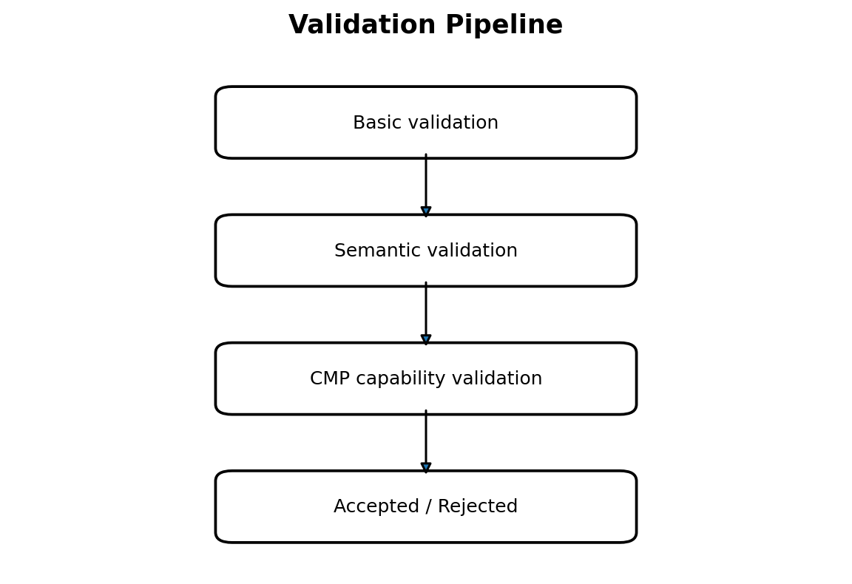
Figure 3-2. Validation stages and outcome.

3.4.1 Admission vs Reconciliation Validation
Validation type | Admission webhook | Reconciliation
Syntax and annotation parsing | Yes | Repeated defensively
Cross-field semantic checks | Yes where all input exists | Yes
Endpoint availability | No | Yes
Node to VM mapping | No | Yes
CMP capability discovery | Only static capability configuration | Yes when runtime-dependent
Ownership conflict | No | Yes
Existing provider drift | No | Yes

Why validation is repeated
Admission improves user feedback but cannot guarantee that runtime dependencies remain valid. Reconciliation therefore validates again before provider mutation. The webhook is not the sole correctness boundary.

3.4.2 Basic Validation Rules
- Service type is LoadBalancer.
- loadBalancerClass matches the configured controller class or the extension is operating in an explicitly configured legacy mode.
- At least one Service port exists.
- Protocol is supported by the current CMP virtual-server capability set.
- Every Service port has a valid nodePort in NodePort backend mode.
- IP family and requested VIP family are supported.
- Extension-prefixed annotations parse successfully and unknown keys are rejected.

3.4.3 Semantic Validation Rules
- Port logical keys are unique after normalization.
- A requested shared VIP does not create conflicting protocol/port listener tuples.
- externalTrafficPolicy=Local is accepted only when local endpoint membership can be represented correctly.
- sessionAffinity=ClientIP is accepted only when a compatible CMP persistence mode exists.
- Monitor protocol is compatible with the pool/member protocol.
- Immutable placement or VIP attributes are not changed through an ordinary update unless a controlled replacement strategy exists.
- Annotation combinations do not request both mutually exclusive internal and external exposure.

3.4.4 Validation Result Model
type ValidationResult struct {
Accepted bool
Warnings []Warning
Errors []FieldError
}
type FieldError struct {
Path string
Code string
Message string
Retryable bool
}
Non-retryable configuration errors set an InvalidConfiguration condition and wait for a Kubernetes object change. Retryable dependency errors, such as a temporarily unavailable network lookup, set a ResolvingBackends or ProviderUnavailable condition and use bounded backoff.

3.5 Backend Discovery
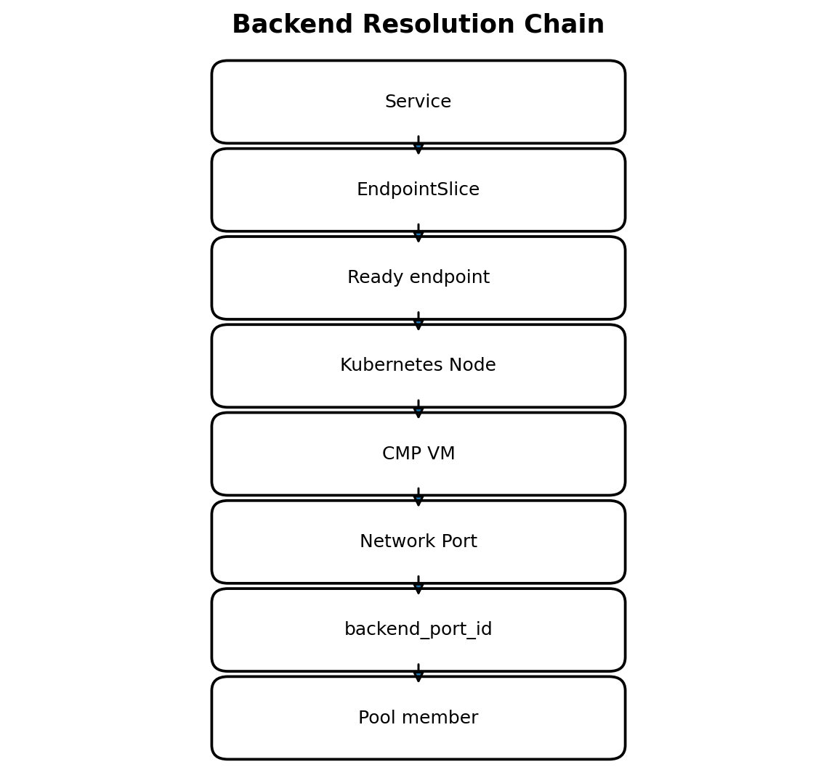
Figure 3-3. Backend resolution from Kubernetes endpoint to CMP network-port identity.
Backend discovery is intentionally isolated behind a BackendResolver interface. Kubernetes identifies application endpoints; CMP requires provider-specific compute and network identities. The resolver joins these domains without coupling the controller or model builder to CMP lookup mechanics.

3.5.1 Input Snapshot
- Normalized Service and Service ports.
- EndpointSlices selected by the standard kubernetes.io/service-name label.
- Nodes referenced by eligible endpoints.
- Provider/Gardener infrastructure context needed to locate CMP tenant, project, network, or region.
- Optional cached read-only CMP lookup data with explicit freshness limits.

3.5.2 Endpoint Selection Algorithm
- List EndpointSlices for the Service and flatten endpoints by port identity.
- Match each EndpointSlice port to the Service port by name first; use protocol and port only where Kubernetes semantics permit an unambiguous match.
- Ignore terminating endpoints unless the configured drain policy intentionally retains them for a grace period.
- Include Ready endpoints. Treat unknown readiness according to a documented conservative policy; default is not ready.
- Require nodeName for NodePort backend mode.
- For externalTrafficPolicy=Local, include a node only when that node has at least one eligible local endpoint for the Service port.
- For externalTrafficPolicy=Cluster, deduplicate eligible nodes because kube-proxy can route NodePort traffic to cluster endpoints.
- Sort the resulting backend candidates by stable node UID or provider ID to produce deterministic model output.

3.5.3 Node to CMP VM Resolution
resolveNode(node):
require node.spec.providerID
providerRef = parseProviderID(node.spec.providerID)
vm = cmpComputeClient.GetByProviderReference(providerRef)
verify vm belongs to expected project/region
return vm.id, vm.resourceType
Node names are not sufficient provider identities. The primary mapping key is the provider ID or an infrastructure-specific immutable machine reference. Name-based fallback should be disabled by default because names can collide or be reused.

3.5.4 Network Port and backend_port_id Resolution
- Collect the node internal addresses that belong to the selected backend network family.
- Query the CMP network API by network/project and IP address, or enumerate VM-attached ports when that API is more precise.
- Filter results to the expected network/subnet and VM ownership.
- Require exactly one matching network port.
- Return the CMP network port identifier as backend_port_id.
- Treat zero matches as retryable only while infrastructure may still be converging; otherwise report BackendResolutionFailed.
- Treat multiple matches as a non-retryable ambiguity until configuration changes.

3.5.5 Resolved Backend Model
type ResolvedBackend struct {
NodeUID string
NodeName string
VMID string
VMResourceType string
Address string
BackendPortID string
NodePort int32
ServicePortKey string
Weight int
LocalEndpointCount int
}

3.5.6 Caching and Consistency
Compute and network lookups may be cached because many Services share Nodes. Cache entries must be keyed by immutable provider identity plus project/network scope, must have a bounded TTL, and must be invalidated on Node provider-ID/address changes. A cache hit never bypasses ownership or network-scope verification.
Failure | Classification | Controller behavior
EndpointSlice not yet created | Retryable dependency | Set BackendsPending and requeue
No ready endpoint | Valid zero-backend state | Keep front end; deploy empty pool or preserve per policy; report NoReadyBackends
Node missing | Retryable during churn | Re-read and requeue
providerID missing | Configuration/infrastructure error | Report NodeIdentityUnavailable
VM lookup timeout | Transient provider error | Backoff and retry
Multiple network ports match | Non-retryable ambiguity | Do not mutate provider; report precise candidates
backend_port_id missing | Provider data incomplete | Retry with limit, then surface error

3.6 Desired State Generation
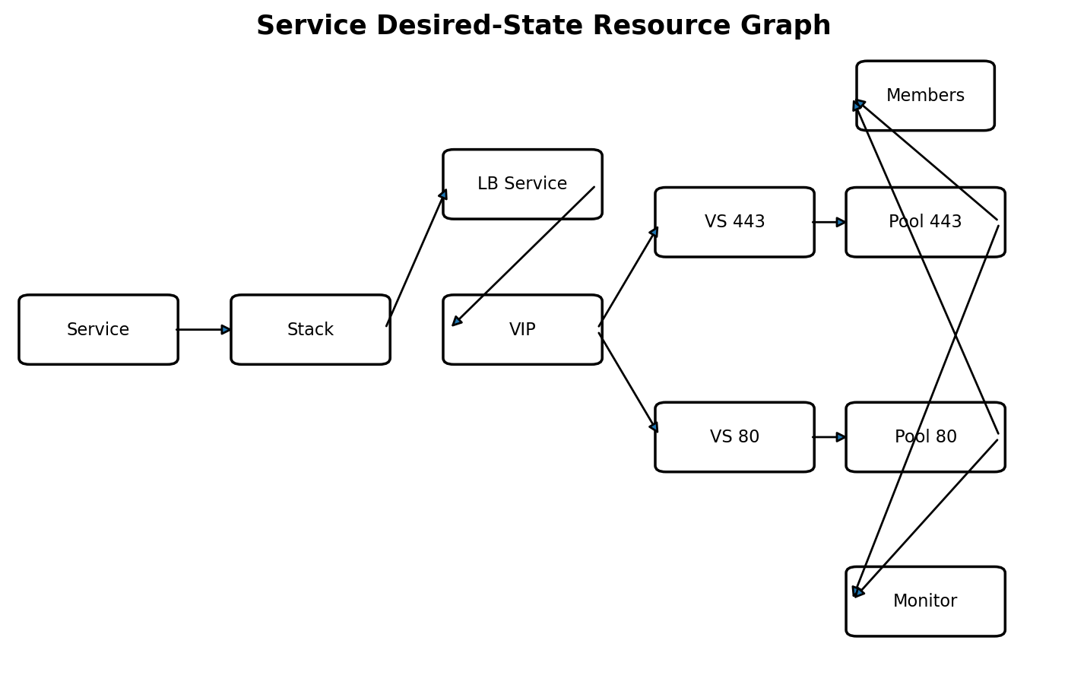
Figure 3-4. Internal desired-state graph for a two-port Service.
The ServiceModelBuilder is a pure transformation over normalized Kubernetes input and resolved backend identities. It performs no CMP calls. This makes model output deterministic, unit-testable, and reusable for dry-run or diff tooling.

3.6.1 Builder Contract
type ServiceModelBuilder interface {
Build(ctx context.Context, in ServiceBuildInput) (*LoadBalancerStack, error)
}
type ServiceBuildInput struct {
Service NormalizedService
Backends []ResolvedBackend
Defaults ProviderDefaults
Scope InfrastructureScope
}

3.6.2 LoadBalancerStack
Model object | Cardinality | Key content
LoadBalancerStack | 1 per Service | Source identity, ownership, graph metadata
LBServiceSpec | 1 | Placement, display name, description, tags
VIPSpec | 1 normally | Requested or allocated address, family, exposure, subnet
VirtualServerSpec | 1 per Service port | Protocol, listener port, VIP reference, pool reference, persistence
PoolSpec | 1 per Service port | Algorithm, member references, monitor reference
MemberSpec | 0..N per pool | backend_port_id, address, NodePort, weight
MonitorSpec | 0..1 per pool or shared compatible monitor | Protocol, interval, timeout, request/expected response

3.6.3 Logical IDs and Ownership Metadata
Logical IDs are internal stable identities used to correlate desired objects with observed provider resources. Provider IDs are discovered outputs and must not be embedded in the desired model as identity.
stackLogicalID = "service/" + serviceUID
lbServiceLogicalID = stackLogicalID + "/lb-service"
vipLogicalID = stackLogicalID + "/vip/default"
virtualServerID = stackLogicalID + "/virtual-server/" + portKey
poolLogicalID = stackLogicalID + "/pool/" + portKey
memberLogicalID = poolLogicalID + "/member/" + nodeUID
monitorLogicalID = poolLogicalID + "/monitor/default"
Ownership field | Produced by | Purpose
sourceKind | Model builder | Kubernetes source type, e.g. Service
sourceNamespace | Model builder | Human and query correlation
sourceName | Model builder | Human correlation
sourceUID | API server, copied by builder | Authoritative source identity
controllerID | Controller configuration | Distinguishes controller installation
logicalID | Model builder | Correlates desired and observed resource
managedBy | Model builder constant | Marks extension ownership domain
role | Model builder per resource | lb-service, vip, virtual-server, pool, member, monitor

Who creates ownership fields?
The Kubernetes API server creates metadata.uid. The model builder creates the ownership envelope for every desired CMP resource using that UID, controller configuration, and the resource role. Deployment managers serialize this envelope into CMP-supported tags, metadata, description fields, or an external tracking record. Typed CMP clients do not invent ownership.

3.6.4 Deterministic Defaults
- Default pool algorithm is centrally configured and materialized into the model.
- Default health monitor is selected from protocol-aware policy.
- Absent optional annotations resolve to explicit model values rather than remaining implicit.
- Lists are sorted by logical ID before deployment and comparison.
- Names are generated from a bounded, collision-resistant scheme containing source name plus UID fragment.

3.7 Resource Mapping

3.7.1 Single-port Service
Kubernetes Service payment-api:443
|
v
CMP LB Service [one application LB boundary]
|
v
VIP [external address]
|
v
Virtual Server [TCP/443 or HTTPS/443 listener]
|
v
Pool [backend policy]
|
v
Members [node backend_port_id + NodePort 32443]
The CMP LB Service is intentionally present. It is the top-level provider resource under which the VIP, virtual server, pools, and related resources are created. A Kubernetes Service is not mapped directly to a VIP alone.

3.7.2 Multi-port Service
Kubernetes port | Virtual Server | Pool | Members
http:80 -> nodePort 30080 | VS http-80 on shared VIP | Pool http-80 | Eligible nodes at 30080
https:443 -> nodePort 30443 | VS https-443 on shared VIP | Pool https-443 | Eligible nodes at 30443
metrics:9100 -> nodePort 30100 | VS tcp-9100 on shared VIP when allowed | Pool tcp-9100 | Eligible nodes at 30100

The default mapping is one Virtual Server and one Pool per Service port, while the LB Service and VIP are shared. This prevents protocol, health-monitor, and backend-port settings from becoming entangled across ports.

3.7.3 Resource Replacement Boundaries
Change | Expected action
Backend membership changes | Update pool members only
Health monitor parameters change | Update or replace monitor; keep VIP and listener stable
Pool algorithm changes | Update pool in place when CMP supports it
Service listener port changes | Create new Virtual Server/Pool, verify, then delete old pair
Requested VIP changes | Controlled VIP/front-end replacement; do not silently mutate if CMP treats address as immutable
Placement/project/network changes | Usually full stack replacement under explicit policy
Service UID changes with same name | Treat as a new owner; old resources belong to deleted source and are cleaned independently

3.8 Deployment Algorithm
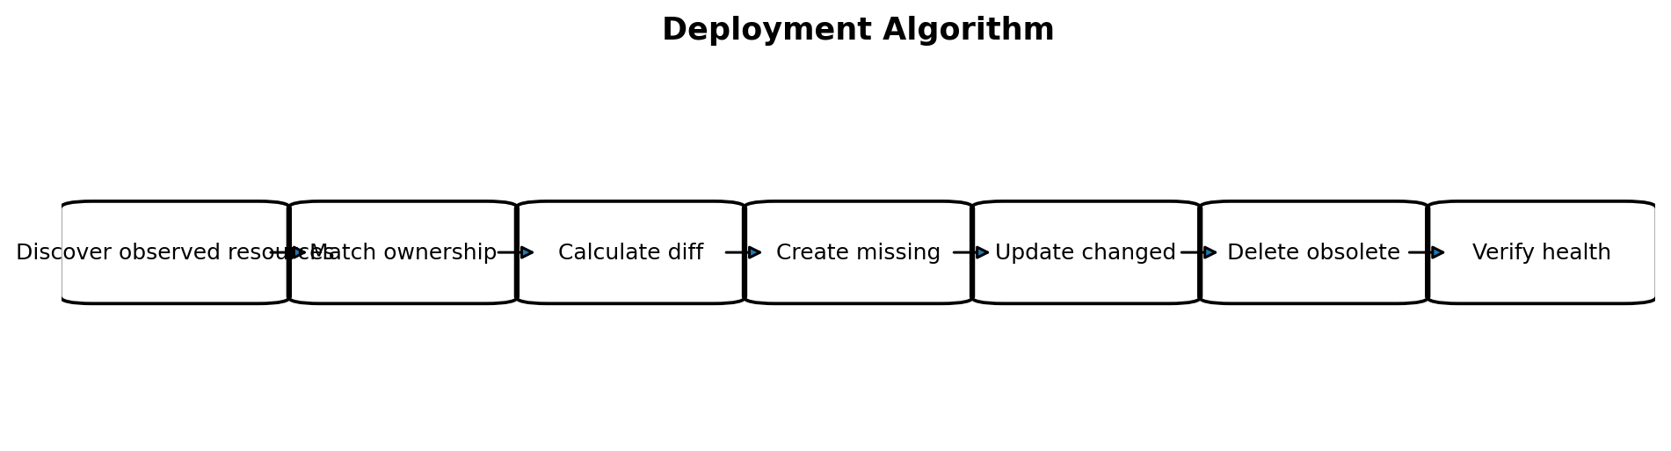
Figure 3-5. Dependency-aware deployment algorithm.
Deployment managers implement resource-specific convergence behind a StackDeployer. The deployer builds an operation plan from desired and observed resource graphs, then executes dependency-safe actions. CMP API calls are made only through typed clients.

3.8.1 Discovery
- Query CMP resources using the strongest available ownership selector, preferably sourceUID plus controllerID.
- If CMP lacks server-side metadata filtering, query within the infrastructure scope and filter locally using normalized ownership metadata.
- Build an ObservedStack containing provider IDs, normalized mutable fields, health, and dependency references.
- Detect duplicate observed resources with the same logical ID and stop automatic mutation until conflict policy resolves them.
- Do not use Kubernetes status as proof that a provider resource exists.

3.8.2 Matching and Diff
for each desired resource D:
O = observedByLogicalID[D.logicalID]
if O absent: plan CREATE(D)
else if !ownershipMatches(D, O): plan CONFLICT
else if immutableFieldsDiffer(D, O): plan REPLACE(O, D)
else if mutableFieldsDiffer(D, O): plan UPDATE(O.id, patch(D,O))
else: plan NOOP
for each observed resource O not matched by desired:
if ownershipMatchesStack(O): plan DELETE(O)

3.8.3 Create Order
- LB Service
- VIP
- Monitors that do not require pools
- Pools
- Pool members
- Virtual Servers and routing references after their dependencies exist
- Provider-specific associations or activation operations
- Readiness verification
Exact ordering must follow CMP API constraints discovered from the Swagger specification. Where CMP creates nested resources through a parent endpoint, the deployment manager still exposes the same logical dependency boundary to the stack deployer.

3.8.4 Update and Delete Order
Operation | Ordering principle
Backend addition | Create member then verify pool health
Backend removal | Drain if supported, then remove member
Listener replacement | Create new pool/listener, verify, then remove old resources
Obsolete child deletion | Members before pool; listener references removed before pool deletion
Full cleanup | Virtual Servers/rules/certificates -> members -> pools/monitors -> VIP -> LB Service
Shared-resource deletion | Delete only when no remaining owned desired resource references it

3.8.5 Idempotency and Retries
- Create uses idempotency keys when CMP supports them; otherwise discovery follows an ambiguous timeout before retrying create.
- Update sends only normalized mutable fields to avoid provider-generated field churn.
- Delete treats not-found as success.
- HTTP 409 or provider in-progress states cause observation and retry, not blind repeated mutation.
- Authentication failure is surfaced immediately and retried at a slower provider-availability cadence.
- Every mutation is followed by read-after-write verification when CMP is asynchronous.

3.9 Status Update
Status communicates externally observable state; it is not the provider inventory database. The status writer receives a typed deployment result and produces a minimal merge patch.

3.9.1 When Status Is Updated
Situation | Status action
Validation failed | Set Accepted=False or Ready=False with non-retryable reason; do not publish a new VIP
Backend resolution pending | Set Ready=False, reason BackendsPending
Deployment in progress | Set Ready=False, reason Provisioning; preserve existing valid ingress address during safe updates
Verified ready | Publish VIP/hostname and Ready=True
Transient CMP failure | Set Ready=False or Degraded=True while preserving last known endpoint if still observed healthy
Deletion in progress | Optionally set Deleting condition; final object may disappear before users observe it

3.9.2 Standard Service Status
status:
loadBalancer:
ingress:
- ip: 203.0.113.42
The extension publishes the provider-assigned VIP as an IP or hostname according to Kubernetes ServiceStatus semantics. It must not publish an address before the CMP front end is verified usable according to the selected readiness policy.

3.9.3 Conditions
Condition | Meaning
Accepted | The Service configuration is supported and valid
BackendsResolved | All required Kubernetes-to-CMP backend identities were resolved
Provisioned | Required CMP resources exist with desired configuration
Ready | Front end is active and provider verification succeeded
Degraded | Service remains partially usable but drift or provider error exists
Deleting | Owned resources are being removed

3.9.4 Conflict-safe Status Patching
- Use status subresource patching, not full-object update.
- Preserve fields written by other controllers where Kubernetes permits multiple writers.
- Do not update transitionTime when condition status and reason are unchanged.
- Retry resourceVersion conflicts by reading the latest Service.
- Emit Kubernetes Events only for meaningful transitions, not every retry.

3.10 Failure Recovery
Recovery is achieved by reconstructing desired state and re-discovering observed state on every reconcile. No correctness-critical workflow depends on in-memory progress.
Scenario | Detection | Recovery action
VIP exists, pool missing | Observed graph is incomplete | Keep owned VIP; create missing pool and remaining children
Pool exists with stale members | Desired/observed diff | Add and remove members only
Controller restarts after create timeout | Provider response lost | Discover by ownership/idempotency key before issuing another create
CMP returns asynchronous provisioning | Resource health/state not ready | Requeue with bounded polling; do not recreate
CMP timeout during update | Outcome ambiguous | Read observed resource and compare normalized fields
Out-of-band field modification | Drift detected | Restore managed fields; ignore documented provider-owned fields
Resource ownership metadata removed | Ownership verification fails | Stop destructive actions and report OwnershipConflict
Duplicate logical resources | Discovery finds >1 match | Mark conflict; apply explicit duplicate cleanup only under safe policy
Node replacement | Old node disappears, new provider ID appears | Add new member, verify, then remove old member
No ready backends | Desired member set empty | Keep or disable front end according to policy; report NoReadyBackends
Status patch fails | Kubernetes API conflict/unavailable | Provider remains converged; retry status patch without repeating unnecessary mutations

3.10.1 Error Taxonomy
Class | Examples | Requeue behavior
InvalidInput | Unsupported protocol, ambiguous annotations | No timed retry; wait for object change
DependencyPending | EndpointSlice absent, VM not yet visible | Short bounded retry
ProviderTransient | Timeout, 429, 5xx | Exponential backoff with jitter
ProviderAuth | Invalid credential/signature | Slow retry and prominent event/metric
Conflict | Foreign ownership, duplicate logical IDs | No destructive mutation; periodic observation
TerminalProvider | CMP rejects valid model as unsupported | Surface ProviderRejected; retry only after relevant change

3.10.2 Observability Requirements
- Reconcile duration and result counters labelled by phase, not by Service name.
- CMP request metrics by operation/resource/status code with sensitive values removed.
- Backend-resolution failure counters by reason.
- Current managed stacks, ready stacks, degraded stacks, and deletion backlog gauges.
- Structured logs containing source UID, namespace/name, logical ID, provider ID, and reconcile correlation ID.
- Kubernetes Events for user-actionable failures and successful initial provisioning.

3.11 Delete Flow
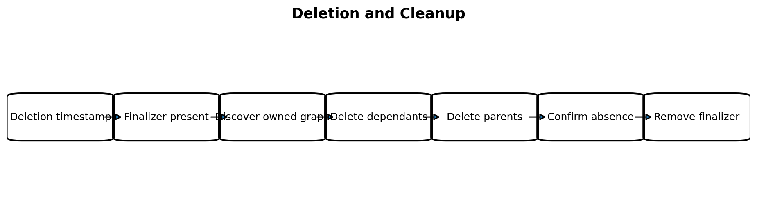
Figure 3-6. Finalizer-driven cleanup flow.

3.11.1 Finalizer Ownership
The Service controller adds a dedicated finalizer only after the Service is accepted for management and before creating CMP resources. The finalizer means “provider cleanup may be required”; it is not proof that provider resources currently exist.
networking.f5.gardener.cloud/service-load-balancer-finalizer

3.11.2 Cleanup Algorithm
- Read the deleting Service and reconstruct its source ownership identity from metadata.uid.
- Discover all CMP resources owned by that source UID and controller ID within the infrastructure scope.
- Build the observed dependency graph even when current Kubernetes ports or annotations are no longer valid.
- Delete dependants before parents. Treat not-found as success.
- Poll asynchronous deletions until absence or a documented terminal state is observed.
- If a resource is foreign-owned or ownership is ambiguous, stop and surface CleanupBlocked rather than deleting it.
- After no owned resources remain, remove the finalizer with a conflict-safe patch.

3.11.3 Why Cleanup Cannot Depend Only on Current Desired State
A deleting Service may have been modified before deletion, may no longer pass validation, or may be missing referenced Kubernetes objects. Cleanup must therefore be driven by immutable source ownership and observed provider resources, not solely by rebuilding the current desired model.

3.11.4 Force and Retain Policies
Policy | Default | Design requirement
Retain provider resources on Service delete | Disabled | Allowed only as an explicit administrative policy with clear ownership transfer semantics
Force finalizer removal after timeout | Disabled | Manual operator action; automatic force risks leaks or foreign deletion
Delete protection in CMP | Honoured and reported | Controller must not silently bypass provider protection
Orphan cleanup | Separate operator workflow | Must prove ownership and infrastructure scope before deletion

3.12 Sequence Diagrams
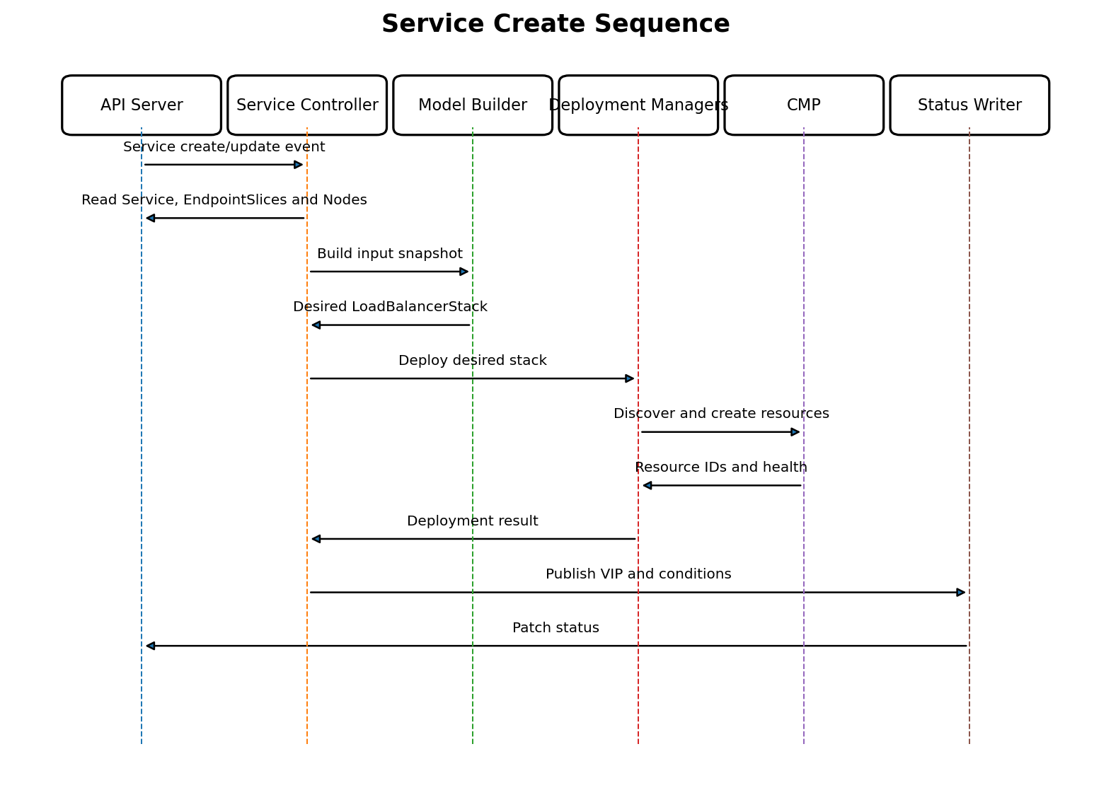
Figure 3-7. Service creation and initial provisioning.
The initial create path publishes status only after deployment managers report that required resources are present and the selected readiness check succeeds.
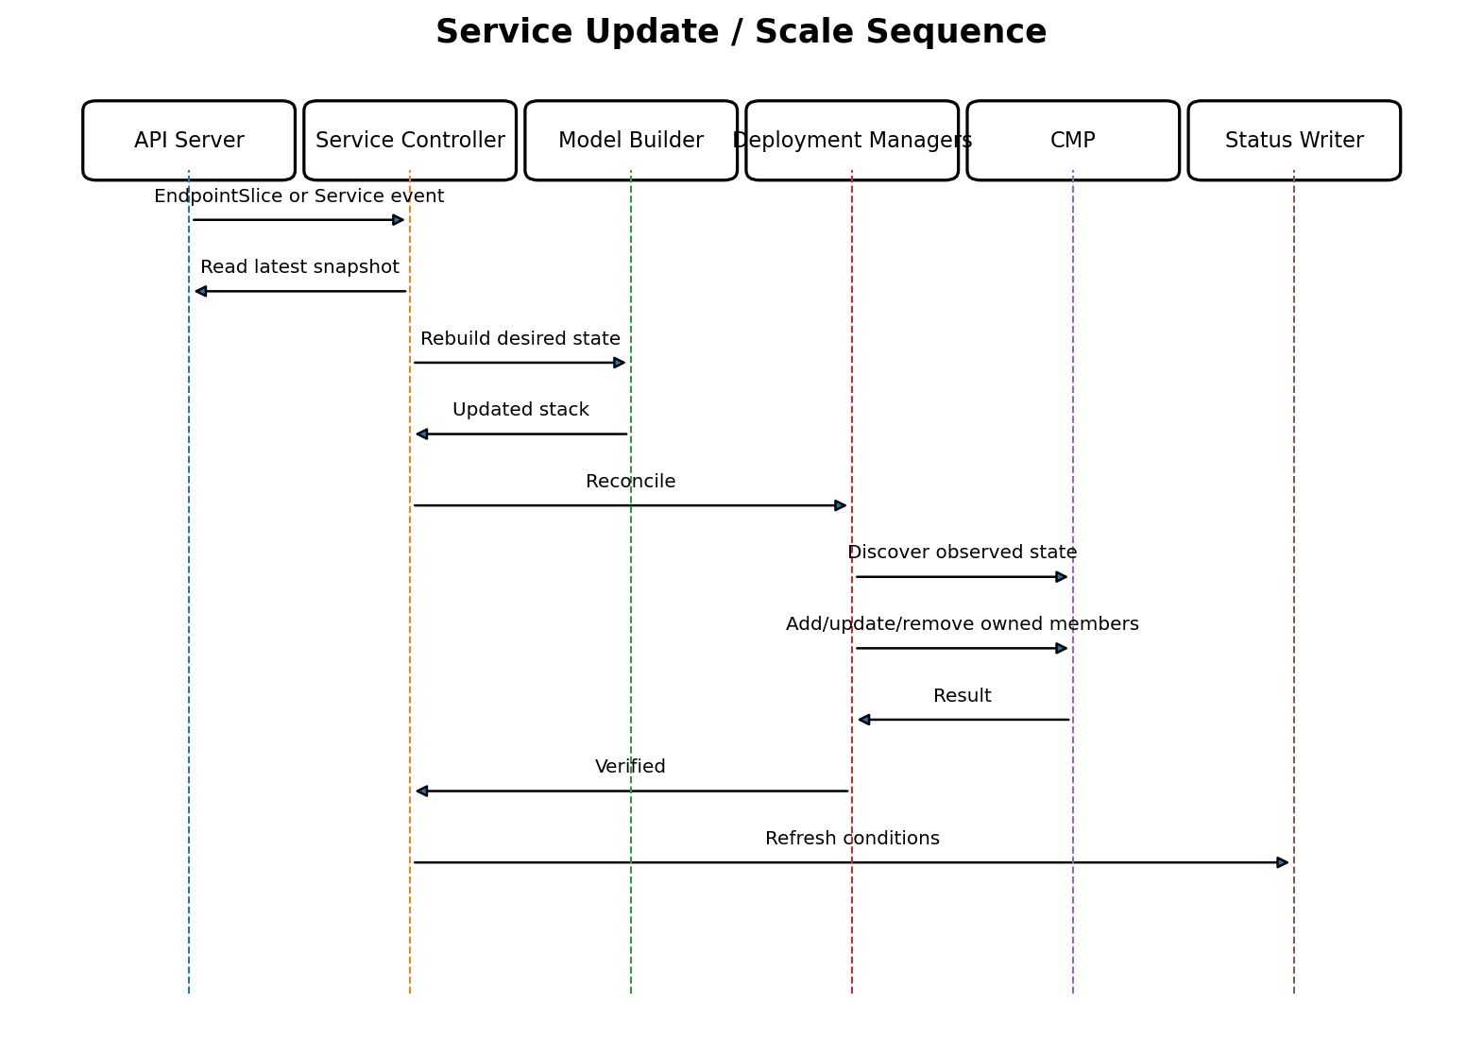
Figure 3-8. Service update, scale-up, scale-down, and backend churn.
Scale events normally change only member resources. The model is rebuilt in full, but the diff plan protects the stable LB Service, VIP, Virtual Servers, and Pools from unnecessary recreation.
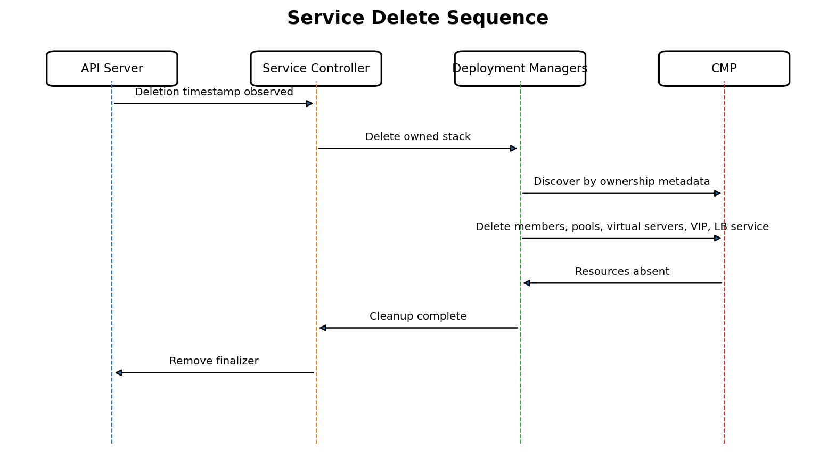
Figure 3-9. Service deletion and finalizer removal.

3.12.1 State Machine
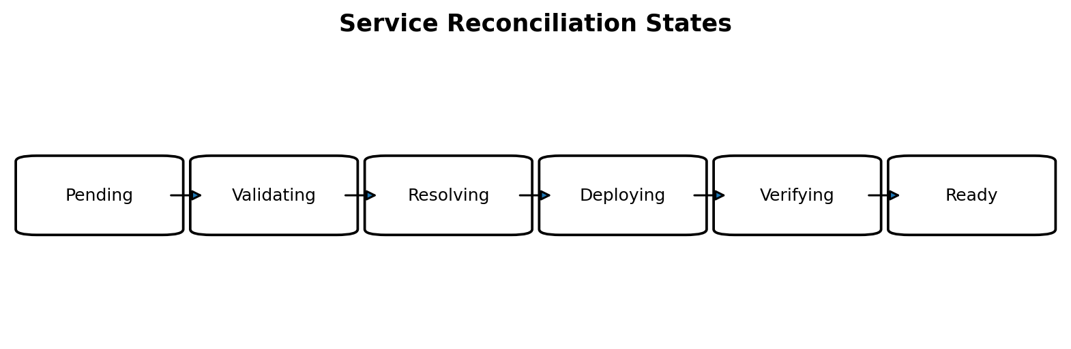
Figure 3-10. Main reconciliation states. Any state may transition to Degraded or Deleting.
State | Entry condition | Exit condition
Pending | Event received or resync | Latest object read
Validating | Eligible non-deleting Service | Validation accepted
Resolving | Kubernetes snapshot valid | Required backend identities resolved
Deploying | Desired stack built | Operation plan completed
Verifying | Resources created or updated | Readiness confirmed
Ready | Status published | New event, drift, or resync
Degraded | Retryable failure or drift | Recovery succeeds or input changes
Deleting | Deletion timestamp with finalizer | Owned provider graph absent

3.12.2 Node Replacement Flow
- EndpointSlice/Node events enqueue the Service.
- The resolver returns a new member for the replacement Node and omits the old Node when it is no longer eligible.
- Diff creates the new member before deleting the old member when both are temporarily visible.
- Pool verification confirms at least the required healthy capacity.
- The old member is drained and removed.
- No VIP, Virtual Server, or Pool replacement occurs.

3.13 Design Decisions
Decision | Rationale | Consequence
Use NodePort backends | CMP/F5 integrates with node network ports and stable node-level reachability | Requires nodePort allocation and Node-to-VM-to-port resolution
Do not use Pod IPs by default | Pod addresses are ephemeral and may not be directly reachable or representable in CMP | EndpointSlice still determines node eligibility, but member address/identity is node based
One Virtual Server per Service port | Listeners have independent protocol, port, persistence, monitor, and pool lifecycle | Multi-port Service creates multiple listener/pool pairs
One Pool per Service port | Backend NodePort and health semantics differ by port | Backend updates remain isolated per port
Share LB Service and VIP across compatible ports | Matches one Kubernetes Service external identity and avoids unnecessary addresses | Port/protocol conflicts must be validated
Backend resolution outside controller | Separates Kubernetes orchestration from provider identity lookup | Resolver can be unit tested and cached independently
Pure model builder | Enables deterministic tests and clear desired/observed diff | All provider reads happen before or within deployment layer, not during model construction
Ownership based on Service UID | Namespace/name can be reused | Safe adoption, drift repair, and deletion require immutable identity
Validation in webhook and reconcile | Webhook cannot validate runtime provider state | Correctness survives webhook bypass and changing dependencies
Status after verification | Provider create acknowledgement may be asynchronous | Users see an endpoint only when it is operational by defined policy

3.13.1 externalTrafficPolicy
Value | Backend model
Cluster | One member per eligible worker node; kube-proxy may forward to endpoints on other nodes
Local | Only nodes with an eligible local endpoint are members; preserves source IP where the data path supports it

The exact data-plane behavior must be confirmed for the cluster CNI, kube-proxy replacement, and F5 configuration. The controller must not claim source-IP preservation unless the complete path supports it.

3.13.2 Session Affinity
Kubernetes ClientIP session affinity may map to a CMP/F5 source-address persistence profile. Support is conditional on verified CMP API fields. If the API cannot configure or reference persistence safely, the Service is rejected rather than silently ignoring sessionAffinity.

3.13.3 Health Monitoring
- TCP is the safe default for generic TCP Service ports.
- HTTP/HTTPS monitors require explicit path, expected status/body policy, and TLS behavior.
- For externalTrafficPolicy=Local, health semantics must ensure nodes without local endpoints are not considered healthy members.
- Monitor interval and timeout must satisfy CMP validation constraints and avoid aggressive load.
- Application-specific monitor settings belong in typed annotations or a future policy CRD, not arbitrary free-form JSON.

3.13.4 Security Decisions
- CMP credentials are read from Kubernetes Secrets and never copied into desired models, status, events, or logs.
- Typed clients own Ce-Auth/HMAC signing and TLS configuration.
- Controller RBAC is restricted to required Services, EndpointSlices, Nodes, Events, Secrets/configuration, and status/finalizer updates.
- Provider operations are scoped to the configured CMP tenant/project/network.
- Ownership metadata is validated before every destructive mutation.
- User-provided names and annotations are sanitized before sending to CMP.

3.14 Summary and Implementation Checklist
The Service design translates one Kubernetes LoadBalancer Service into one owned CMP load-balancer stack. The stable top-level resources are an LB Service and normally one VIP. Each Service port receives an independent Virtual Server and Pool. EndpointSlice determines eligible backends, while a dedicated resolver converts node identity into CMP VM and backend_port_id values. Deployment managers converge this graph using ownership-aware discovery, typed clients, ordered operations, verification, and finalizer-based cleanup.

3.14.1 Package-Level Implementation Checklist
Area | Required implementation
controllers/service | Reconciler, watches, predicates, finalizer flow, event/status coordination
service/validation | Basic, semantic, annotation, capability validators
service/backend | EndpointSlice selection, Node policy, VM/port resolver, cache
service/model | Normalizer, logical IDs, ownership envelope, LoadBalancerStack builder
deploy/stack | Discovery, graph matching, diff planning, ordered execution, verification
deploy/lbservice | LB Service manager
deploy/vip | VIP manager
deploy/virtualserver | Virtual Server manager
deploy/pool | Pool and member manager
deploy/monitor | Health monitor manager
cmp/client | Typed clients, Ce-Auth/HMAC transport, retries, error normalization
status | Conditions, ServiceStatus patching, events
observability | Metrics, structured logs, trace/correlation IDs
webhooks | Admission validation and annotation schema

3.14.2 Minimum Test Matrix
Test level | Essential cases
Unit - validation | Supported/unsupported protocols, duplicate ports, annotations, policy combinations
Unit - builder | Single port, multi-port, empty backends, Local/Cluster, deterministic ordering, ownership fields
Unit - resolver | Ready filtering, node deduplication, provider ID parsing, zero/multiple port matches, cache invalidation
Unit - diff | Create, update, replace, delete, no-op, ownership conflict, duplicate observed resources
Integration - fake CMP | Initial create, timeout ambiguity, async provisioning, partial resource graph, drift repair
Envtest/controller | Watches, finalizer, status conflict, deletion while invalid, EndpointSlice churn
End-to-end | Service create/update/delete, multi-port, scale up/down, node replacement, controller restart, CMP outage

3.14.3 Definition of Done
- All supported Service fields have explicit mapping and validation behavior.
- No controller code directly calls raw CMP endpoints.
- Every provider resource contains verifiable ownership metadata.
- Reconciliation is idempotent under duplicate events and ambiguous provider responses.
- Scale and endpoint changes modify members without recreating the front end.
- Deletion removes the complete owned graph before finalizer removal.
- Status and events clearly distinguish invalid input, pending dependencies, provider failures, conflicts, and readiness.
- Unit, integration, and end-to-end tests cover the minimum matrix above.

Appendix A - Core Interfaces
type BackendResolver interface {
Resolve(ctx context.Context, snapshot KubernetesSnapshot) ([]ResolvedBackend, error)
}
type StackDeployer interface {
Deploy(ctx context.Context, desired *LoadBalancerStack) (DeploymentResult, error)
Delete(ctx context.Context, owner OwnershipKey, scope InfrastructureScope) error
}
type CMPVirtualServerClient interface {
List(ctx context.Context, scope Scope, filter OwnershipFilter) ([]VirtualServer, error)
Get(ctx context.Context, id string) (*VirtualServer, error)
Create(ctx context.Context, req CreateVirtualServerRequest, idempotencyKey string) (*VirtualServer, error)
Update(ctx context.Context, id string, req UpdateVirtualServerRequest) (*VirtualServer, error)
Delete(ctx context.Context, id string) error
}

Appendix B - Example Normalized Desired Model
stack:
logicalID: service/3b6d...-uid
owner:
sourceKind: Service
sourceNamespace: payments
sourceName: payment-api
sourceUID: 3b6d...-uid
controllerID: gardener-extension-f5/default
managedBy: gardener-f5-alb-extension
lbService:
logicalID: service/3b6d...-uid/lb-service
vip:
logicalID: service/3b6d...-uid/vip/default
family: IPv4
virtualServers:
- logicalID: service/3b6d...-uid/virtual-server/name:https
protocol: TCP
port: 443
poolRef: service/3b6d...-uid/pool/name:https
pools:
- logicalID: service/3b6d...-uid/pool/name:https
algorithm: ROUND_ROBIN
members:
- backendPortID: cmp-port-7e3a
address: 10.20.1.14
port: 30443

